 **CS 341: Web Technologies**

LAB EXERCISE 9b (Wednesday, 7th November 2018)

**Instructions:** This lab aims to guide you to connect to MySQL database using PHP Data Object (PDO). DO THIS LAB INDIVIDUALLY.

**TASK:** To connect to MySQL database server using PDO object.

**Activity 1**

Before connecting to a MySQL database, you have to specify the following information:

* MySQL data source name or DSN:  specifies the address of the MySQL database server. You can use IP address or server name e.g., 127.0.0.1 or localhost
* MySQL database name: indicates the name of the database that you want to connect to.
* Username and password: specify username and password of the MySQL’s user that you use to connect to the MySQL database server. The account must have sufficient privileges to access the database specified above.

We will use:

* The local MySQL database server so the DSN is localhost.
* The testdb as the sample database.
* The root account with a blank password, just for the sake of demonstration.

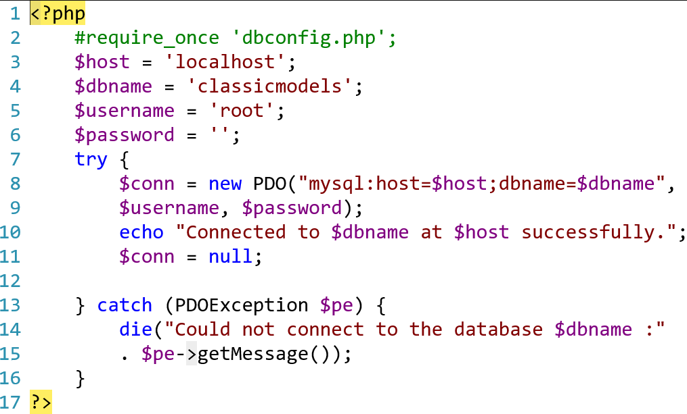

How the script works.

* We included the dbconfig.php file into the script by using the require_once function.
* Inside the try block, we created a new PDO object with three arguments: connection string, username, and password. The connection string is composed of $host and $dbname variables in the dbconfig.php file.
* If the connection to the MySQL database established successfully, we displayed a success message. If there was any errors or exceptions, PHP issued a PDOException that contains the detailed error message. We call the getMesage() method of the PDOException object to get the detailed message for displaying.

**Activity 2**

Writing queries to interact with the MySQL database:

Refer to <https://www.youtube.com/watch?v=hSS1Ml6YOt8>

